**DEMO 2**

1. **Layout Variant**

Variant of this layout for horizontal orientation as shown in the figure below.

**Landscape**



**Tablet(x-large)**



1. **Coding Challenge 2**

Hello Toast Challenge2





**3. Change the layout to linear layout**

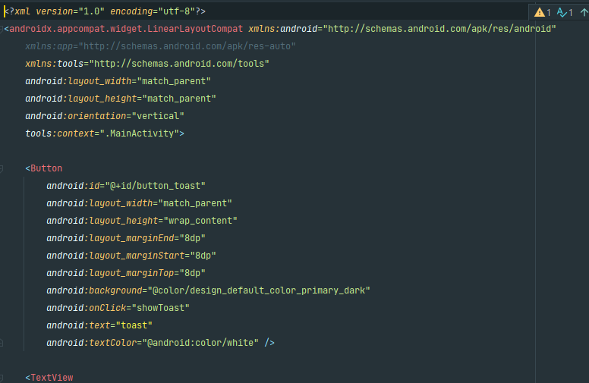



**4. Change the layout to Relative Layout**

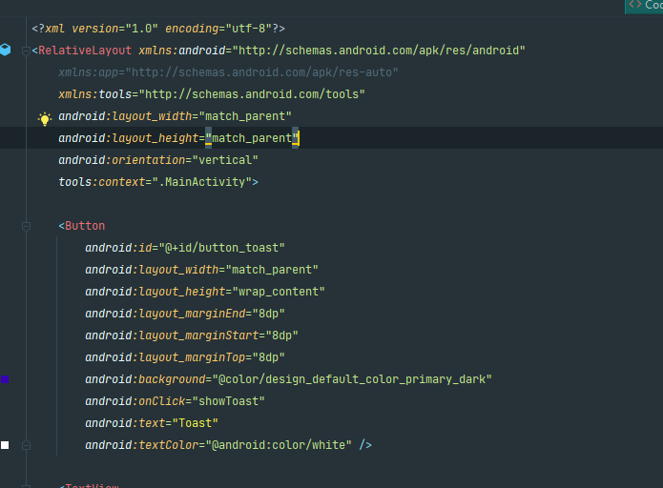



**5. Homework**

**HelloConstraint**

